Written Brief on Bill S-203, An Act respecting a federal framework on autism spectrum disorder

By Autistics United Canada, April 2022
In submission to the Standing Senate Committee on Social Affairs, Science and Technology
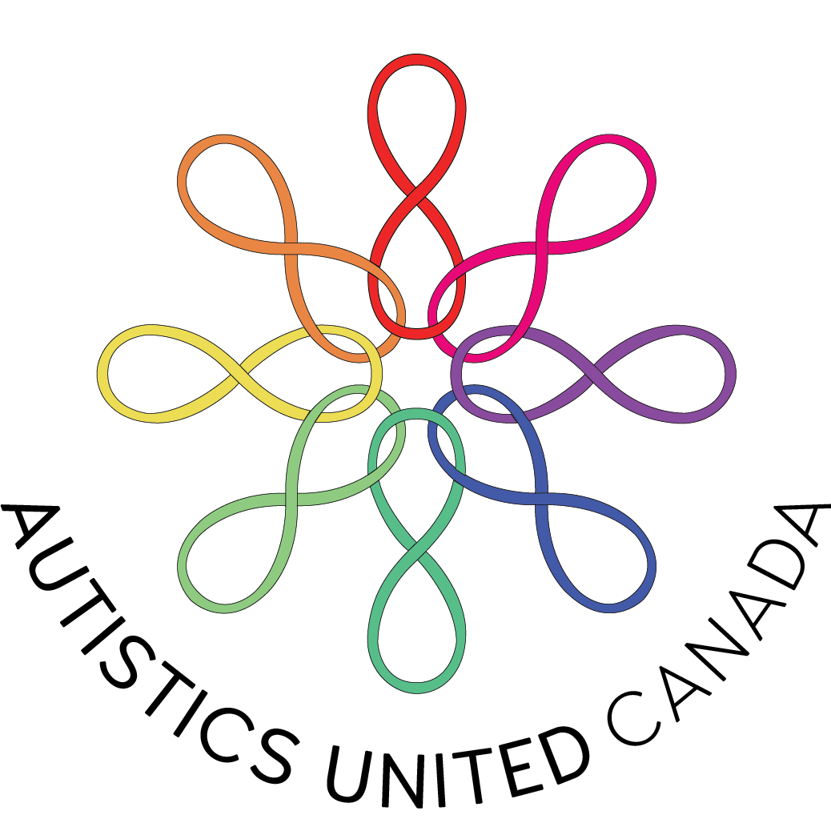

Introduction
Autistics United Canada (AUC) is a grassroots autistic-led organization representing diverse autistic youth and adults across the part of Turtle Island colonially known as Canada. Our mission is to promote self-advocacy and autonomy, improve autistic well-being, and enact cultural change through a disability justice lens. AUC is a member of the Autistic Advocacy Coalition of Canada and an international affiliate of the Autistic Self-Advocacy Network. Learn more about us at AutisticsUnitedCA.org.

This written brief includes comments and recommendations regarding Bill S-203, An Act respecting a federal framework on autism spectrum disorder. Representatives from Autistics United Canada and Autistics for Autistics spoke before the Standing Senate Committee on Social Affairs, Science and Technology on March 20, 2022, and were invited to follow up with additional written comments.

A Shift from Autism as Deficit to Neurodiversity, Disability Rights, and Disability Justice
Autistic and otherwise disabled people have long called for a shift away from the archaic medical model of disability, where disabled people are viewed as abnormal, disordered, lacking versions of human beings. The United Nations Convention on the Rights of Persons with Disabilities (UN CRPD), ratified by Canada in 2010, instead adopts language of the social model of disability and a disability rights approach. In order for Bill S-203 to comply with the UN CRPD, greater recognition of the social and political dimensions of autism as a disability must be included. Beyond compliance with the CRPD, we call for 1) language affirming neurodiversity and reinforcing the protection of neurodivergent people’s rights to full life and self-determination, as Chile has done in its own constitution; 2) language affirming the communication rights of autistic and otherwise disabled people, as in the Communication Bill of Rights in the U.S.; and 3) language committing to an intersectional approach to systemic ableism and its multiple impacts on multiply-marginalized disabled people, in line with the principles of disability justice.

Our recommendations:
- Avoid stigmatizing, pathologizing language such as “disorder”, “suffering”, and “impairment”, “symptoms”, “treatment” and “intervention”
- Use strengths-based neurodiversity-affirming language in line with the social model of disability such as “disability”, “access barriers / lack of access”, “strengths”, “challenges”, “traits”, and “supports and services”
- Use “Autism Spectrum Disorder” or “Autism Spectrum Condition” only when required to refer specifically to the DSM-5, and “autism” in all other cases
- Use “acceptance”, “appreciation” and “celebration” rather than “awareness”
- Include in the Preamble the recognition of and valuing of neurodiversity as part of human diversity
- Include in the Preamble the recognition of the right of autistic people to achieve autonomy and self-determination (as per Article 3 of the UN CRPD), and their “right to affect, through communication, the conditions of their existence” (as per the Communication Bill of Rights)
- Include in the Preamble the recognition of the multiple impacts of intersecting systems of discrimination and oppressions on disabled Black, Indigenous People of Colour (BIPOC), disabled women, disabled Two-Spirit, Lesbian, Gay, Bisexual, Transgender, Queer and/or Questioning, Intersex, Asexual and/or Aromantic (2SLGBTQIA+) people, low-income disabled people, disabled migrants and refugees, incarcerated disabled people, disabled precarious workers, disabled people without houses, and other multiply marginalized disabled people, and the need for an intersectional approach to address them

Please refer to Appendix A for further resources and recommendations on language and symbolism.

Duty to “Closely Consult with and Actively Involve” Autistic Representative Organizations
The state’s duty to closely consult with, actively involve, and give priority to the views of autistic peoples’ representative organizations is enshrined in the UN CRPD. This duty is enumerated in ‘General comment No. 7 (2018) on the participation of persons with disabilities, including children with disabilities, through their representative organizations, in the implementation and monitoring of the Convention.’
It is crucial to differentiate between autistic representative organizations and other organizations with an interest in autism:

Organizations of persons with disabilities should be distinguished from organizations “for” persons with disabilities, which provide services and/or advocate on behalf of persons with disabilities, which, in practice, may result in a conflict of interests in which such organizations prioritize their purpose as private entities over the rights of persons with disabilities. States parties should give particular importance to the views of persons with disabilities, through their representative organizations, support the capacity and empowerment of such organizations and ensure that priority is given to ascertaining their views in decision-making processes. (Part II, B (13))

Autistic community organizers and advocates are experts. Autitistics United Canada in particular represents a diverse group of autistic people, including autistic BIPOC, autistic women, autistic 2SLGBTQIA+ people, low-income autistic people, autistic refugees and migrants, autistic precarious workers, autistic incarcerated people, autistic people without houses, multiply-disabled autistic people, and non-speaking autistic people, and work closely with our members. We have a unique understanding of our community’s needs, along with lived experience—which in itself is an oft-undervalued form of expertise.

Autistic people have important insight and expertise on what autism is and how to support and communicate with other autistic people. This has been reflected in the literature on the double empathy problem, autistic communication, and autistic expertise on autism. Please read through the introductory sources in Appendix B on autistic expertise and the importance of consulting with autistic people and our representative organizations.

Consultation with autistic peoples’ representative organizations “should begin in the early stages and provide an input to the final product in all decision-making processes” (Part II, C, 15).
As a grassroots, volunteer-run organization led by autistic people, it has been difficult for us to provide feedback in a timely manner. We do not have the funding and staffing resources to match the capacity of other stakeholders, particularly those led by non-disabled people. We would like more time and support to adequately consult on the direction of this process, honouring crip time and a diversity of access needs. It is also important to financially support disabled persons’ representative organizations so that they can be closely consulted (Part III, 59-64), e.g.:
The Committee recommends that States parties adopt criteria to allocate funds for consultation, including by:
(a) Providing funds directly to organizations of persons with disabilities, avoiding third-party intermediation;
(b) Prioritizing resources to organizations of persons with disabilities that focus primarily on advocacy for disability rights;
(Part III, 61)
As Canada continues to implement the CRPD, it is critical for an evaluation of the current state of affairs of autism research and practice in Canada to be informed by the CRPD. In addition to direct consultation and collaboration with autistic people and autistic-led organizations, a CRPD expert could ensure that national autism and disability policy is aligned with the best standards of disability rights law.
Our recommendations:
- Include language in the Preamble affirming the principle of “Nothing About Us Without Us”
- Require that consultations by the Minister of Health are physically, cognitively, sensorily, and financially accessible for autistic people, autistic-led organizations, and autistic people living at multiple intersections of marginalization
- Ensure that the accountability measures for the use of federal funds includes representation of diverse autistic people and autistic-led organizations in oversight bodies
- Require the Minister of Health to consult with UN CRPD implementation specialists in the creation of the framework to ensure the consultation process and framework meet the highest standards of international disability law

Independent, Disaggregated Demographic Data Collection
Federal and provincial governments should collect independent demographic data on autistic people to address systemic ableism, and how it interacts with systemic racism, sexism, ageism, homophobia/homomisia, transphobia/transmisia, classism, and other forms of discrimination and oppression.
This data should include income, employment, education, incarceration, housing (including visible and invisible houselessness, institutionalization, and collective housing), mental and physical health, access to basic needs (food, clothing, shelter, transportation), and access to assistive devices, supports, and services. Additional demographic data should be collected on intersections regarding geographic location (including First Nations reserves), gender (including two-spirit, transgender, and gender diverse identities), age (including children and seniors), race, additional disabilities, faith, and citizenship status.
While Statistics Canada collected data on autistic people over 15 through the Canadian Survey on Disability, children were not included in the survey. It also excluded disabled people living in institutions and other collective dwellings, on Canadian Armed Force bases, and on First Nations reserves. Some of the factors mentioned above were not taken into account.
The Canadian Autism Spectrum Disorders Alliance was also awarded funding to conduct a National Needs Assessment Survey, but this was not an independent collection of data by the government. As well, less than 4% of survey respondents were autistic themselves.
Similar calls to independent government data collection have been made. In 2020, BC’s Human Rights Commissioner and Information and Privacy Commissioner published a report advising the BC government on the collection of disaggregated data to address systemic racism. There is a need for collection of disaggregated data according to demographic categories (e.g. race, gender, types of disability) to highlight systemic inequalities across different axes of oppression.
Our recommendations:
- Require the framework to include the independent government collection of disaggregated demographic data on autistic people to inform supports, research, and education, and to provide an evidence base to strengthen accountability measures
- Require that government demographic surveys on autistic people be created in consultation with autistic people to ensure that they are relevant, sensitive, and accessible

Integrating Autism Policy within Disability and Human Rights Policy
Autistic-led advocacy organizations like Autistics for Autistics Ontario and Autistics United Canada have repeatedly raised concerns about the siloing of autism policy in lieu of integrating it within disability and human rights policy. Autism is a disability, yet we are concerned that it is being treated as a separate category from other disabilities in policies, with autistic people not being afforded the same rights and protections as other disabled groups.

Our recommendation:
- Require that the framework be couched within existing disability and human rights policy such as the United Nations Convention on the Rights of Persons with Disabilities, the Accessible Canada Act, and the Canadian Charter of Rights and Freedoms

Investing in Strengths-Based, Neurodiversity Affirming Services
One of the largest concerns our autistic members have with the framework is that it would lead to increased funding of more coercive and harmful behavioural interventions, such as Applied Behavioural Analysis, over diverse neurodiversity-affirming supports. Self-reported accounts from autistic survivors of ABA and increasing research detail long-term trauma, experiences of abuse and resulting mental illness and suicidality. There is also a strong connection between camouflaging or hiding autistic traits (which ABA and other behavioural interventions promote) the devastatingly high suicide rates of autistic youth and adults. Autistic people’s experiences of these behavioural interventions constitute a violation of our basic human rights. Policy-makers need to take survivors of ABA seriously and ensure that autistic children and adults alike have autonomy, self-determination and choice over the supports and services we receive.

According to Autistics United Canada’s #AskingAutistics About National Autism and Disability Policy Survey (N=126) launched in October 2020, the autism service rated least helpful by autistics was behavioural intervention. 70% of autistic respondents found that it was somewhat or very unhelpful for children, with the majority finding it very unhelpful. 75% of respondents found it unhelpful for adults, with 2/3rds finding it very unhelpful. Another survey with over 11,000 respondents found that 88% of autistic people disagreed with the use of ABA for children, including 72% of those who experienced ABA themselves.

Respondents to AUC’s survey were more favourable towards other types of services, such as developmental and relationship-based therapies, occupational therapy, speech therapy, psychotherapy, music, art, and recreational therapy, and respite care.
While autistic responses to social skills classes were mixed, an overwhelming majority were in favour of recreational and social groups for children and adults, and autistic peer support and mentorship for children. Autistic peer support and mentorship by and for autistics was the highest rated support, with 94% rating it as helpful. As for services for adults, those rated most helpful were employment and education support and accommodations (88% each) and expanded financial assistance such as through disability benefits (91%). However, this did not extend to sheltered workshops, for which ratings were decidedly mixed.
These results indicate that diversity of services is needed, with an emphasis on strengths-based neurodiversity-affirming services across multiple sectors, including ones led by autistic people themselves.
There is further concern raised by autistic-led advocacy groups like Autistics for Autistics over the inefficient misuse of federal funds for autism initiatives through sole-source contracting and lack of competitive bidding processes and follow-up assessments.
Our recommendations:
- Require the framework to provide measures to develop research networks and knowledge dissemination resources on best strengths-based neurodiversity-affirming practices
- Require a competitive funding environment, requests for proposals, and assessments on the return on investment for autism initiatives and projects

Deinstitutionalization and Universal Supports for Independent Living
Autistics United Canada is concerned that the framework will further segregation and institutionalization of autistic people. We object to the growing trend of transinstitutionalization, building neo-institutions–whether it be day-institutions for autistic toddlers or group homes for disabled children and adults–that replicate patterns of custodial care, inhumane treatment, and neglect of institutions they purport to replace, albeit with fewer clients and residents. Instead, we call for expanded respite services, flexible home care services, and universal supports such as universal basic income, universal pharmacare, and housing-first strategies to allow autistic people the freedom to live outside of institutional settings.

In our survey, a quarter of autistic respondents were living off of under $2000/month, even with support from others such as family and friends. Two-thirds of autistics reported struggling to apply for provincial and/or federal financial benefits for disabled people.

Many reported concerns about their living situation: around a third reported being concerned about lack of permanent housing, a third concerned about the condition of their housing, and a quarter feeling unsafe in their home.

Two thirds struggled in the past 6 months to pay for basic needs, including food, housing, heat and electricity, telecommunications, medical and accessibility needs, transportation, and care for a dependent.

Our recommendation:
- Require that that framework must identify measures to further deinstitutionalization across Canada and provide home- and community-based services and universal supports for independent living

Supported Decision-Making
The high profile case of Britney Spears has put the risks of abuse under conservatorship, guardianship, and substitute decision-making into public consciousness. Supported decision-making is a crucial component of disabled people’s right to self-determination, as enshrined in the UN CRPD. While Canada was the first country to develop legal mechanisms for supported decision-making, there is uneven supported decision-making legislation between provinces and territories. This causes inequitable access to support decision-making for autistic people and their families across Canada, which can also affect their access to federal financial supports such as the RDSP. Autistics United Canada joins other disability organizations in calling for a improved legislation and services to ensure that supported decision-making is more widely accessible and understood by disabled people, supporters and supporting organizations, and financial institutions; that rights advice and advocacy supports are provided to those subjected to substitute decision-making; and that jurisdictions across Canada include best practices for supported decision-making within the law and within disability services.
Our recommendation:
- Require the framework to include measures to improve access to supported decision-making for autistic people and their families

Appendix A: Language and Symbolism
Resources on language and symbolism:
- The Autistic Self-Advocacy Network’s definition of autism, created in consultation with diverse autistic community members.
- Avoiding Ableist Language: Suggestions for Autism Researchers (Bottema-Beutel et al., 2021)
- The Significance of Semantics: Person-First Language: Why It Matters (Brown, 2011)
- Annual Research Review: Shifting from ‘normal science’ to neurodiversity in autism science (Pellicano & den Houting, 2021)
- Neurodiverse or Neurodivergent? It’s more than just grammar (Fletcher-Watson, 2020)
- Do puzzle pieces and autism puzzle piece logos evoke negative associations? (Gernsbacher et al., 2018)
Language and Symbolism We Do Not Recommend | Language and Symbolism We Recommend
Person with autism, person on the autism spectrum, person living with autism | Autistic person
Neurodiverse person | Neurodivergent person; neurodiverse population (referring to neurodivergent and neurotypical people together)
Suffers from, burden, tragedy, puzzle | Experiencing barriers, lack of support, lack of access, lack of acceptance
Deficit, disorder, symptoms, low/high functioning/severity/needs | Disability, neurodivergence; description of specific strengths, needs, features, characteristics, and traits
Autism Spectrum Disorder, Autism Spectrum Condition | Autism, Autism Spectrum
Autism families, families living with autism | Families of autistic people
Special needs | Description of specific needs and disabilities
Co-morbid | Co-occurring
Treatment, intervention, cure, recovery | Supports and services, quality of life, well-being
Epidemic | Increasing recognition and diagnosis
Blue puzzle piece | Neurodiversity (rainbow infinity) symbol
Non-verbal | Non-speaking
 | Augmentative and Alternative Communication (AAC) user

Appendix B: Autistic Expertise
Gillespie-Lynch, K., Kapp, S. K., Brooks, P. J., Pickens, J., & Schwartzman, B. (2017). Whose Expertise Is It? Evidence for Autistic Adults as Critical Autism Experts. Frontiers in psychology, 8, 438. https://doi.org/10.3389/fpsyg.2017.00438

Milton D. E. (2014). Autistic expertise: a critical reflection on the production of knowledge in autism studies. Autism : the international journal of research and practice, 18(7), 794–802. https://doi.org/10.1177/1362361314525281

Milton, D.E. Autism and the Double Empathy Problem. Scottish Autism Strategy 8th Annual Conference. 2020 Oct. https://youtu.be/YWUsnT1c_5I

Mitchell, P., Cassidy, S., & Sheppard, E. (2019). The double empathy problem, camouflage, and the value of expertise from experience. Behavioral and Brain Sciences, 42.

Murray, F. Autistic People's Organisations (APOs) and Autistic Rights. Scottish Autism Strategy 8th Annual Conference. 2020 Oct. https://youtu.be/F8If1yk3zQI

Used by some researchers, e.g. Girls Questionnaire for Autism Spectrum Condition (GQ-ASC; Attwood et al. 2011). It is a step in the right direction, but still not ideal.

