Guide for Neurodivergent People with Needle Anxiety

If you are nervous about getting the COVID-19 vaccine, here are some tips to help with that. We asked our members for their tips to share with other neurodivergent people.

It is important to note that different techniques work better for different people. Don’t feel pressured to do anything of these you don’t think will help!

Content warning: there is some discussion about needles in the guide, but no detailed or graphic descriptions.

Relaxation Techniques

Source: Migaj (2017)
[Image description: a person sitting at a dock looking out at a lake surrounded by mountains.]

- Conventional relaxation techniques such as progressive muscle relaxation, breathing exercises and visualization exercises are helpful for some.
- Some people may find listening to their favourite music helpful.
- If you have a phone or other mobile device, you may also play games on it or text a friend to help you calm down.

Sensory/Stimming Suggestions

[Image description: photo of various colourful stim toys a wooden table: a snap-and-click fidget, two tangles, a Gyrobi, a pop tube, a Jacob’s Ladder puzzle, a ring with beads, a Slinkie, a fidget cube, and a polar bear-shaped squishie]

- Bring your favourite stim toys, fidgets, or comfort items with you, if you use them to help with anxiety.
- If you have sensory sensitivities around being touched, you can let the person giving you the shot know this.
- The vaccination clinic may be a bit loud. Bringing earplugs, ear defenders, or noise-cancelling headphones can help with sound reduction.

General Preparation Tips

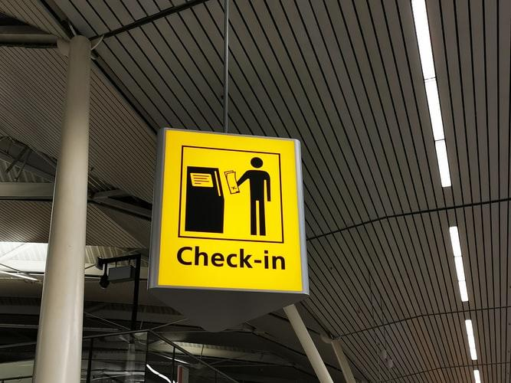
Source: Gies (2020)
[Image description: photo of a sign hung from the ceiling. The sign says “Check-in” and shows a stick person holding a paper and standing near a desk.]
- Plan your trip to the clinic ahead of time. Ask yourself: What will you need to bring? How long will you need to give yourself to prepare and to travel? Will you be going with someone else or by yourself?
- Here is a checklist for some things you may want to bring
- Make sure to give yourself plenty of time to travel to the clinic without being rushed. Try to arrive as close to your appointment time as possible, so you do not have to wait too long either if you are early.
- If you know someone else who has gone to the same clinic where you are booked, you can ask them about their experience and what the process was like at the clinic. For example, how busy was it? How loud/bright was the clinic? What were the steps they had to go through? How long was the line? How accessible was the clinic?
- You can create a script ahead of time of what you want to say to the person giving you your shot. Scripting means preparing what you want to say by writing it down, reviewing it in your mind, and/or practicing saying it. If you use Augmentative and Alternative Communication, you can put the scripts in your AAC device.
- If you think it will help, ask the doctor/nurse to explain the procedure to you ahead of time. Example script: “Before you do anything, can you please explain what you will do step by step?”
- Many clinics will have a place for you to lie down if you think you may fall down or faint. You can ask to be given this. Example script: “I need a place to lie down because I may fall down or faint when I get shots. Do you have somewhere for me to lie down?”
- Some doctors also recommend sitting upright and tensing then relaxing your leg and stomach muscles to prevent fainting. Please discuss with your doctor ahead of time if you are concerned about fainting before trying any new techniques.
- If being touched suddenly makes you more anxious, you can ask them to warn you before touching you. Example script: “I would like to be warned before you touch me if you need to.”
- Sometimes, doctors or nurses may count down before they give you your shot, you can ask to do this (or not do this) if you prefer. Example script if you would like them to count down: “I would prefer it if you count down aloud before you give me my shot.”
Example script if you would not like them to count down: “I would prefer if you don’t count down aloud before you give me my shot.”
- Ask yourself if you would prefer to look away, or look at the procedure when receiving the shot.

Pain Management
Source: 588ku (n.d)
[Image description: graphic of a person holding their shoulder and wincing in pain.]
- If you are worried about pain in your arm from the shot, you may apply over-the-counter, topical anesthetic or numbing cream to your arm before the shot. It makes your arm less sensitive to pain. If you haven’t used them before, please talk to your pharmacist or doctor first. You may also want to try it ahead of time to make sure it works for you.
- If you regularly take painkillers, you can continue taking them. But the National Advisory Committee on Immunization does NOT recommend taking them before or during your shot, if you are taking them only for the vaccine. This is because pain medication taken before or during the shot may interfere with the effectiveness of the vaccine. In the days after your shot, you may take painkillers to help deal with any pain or fever. If you are concerned about the vaccine interacting with any medications you take, please talk to your doctor.
- Some people may experience side effects such as a sore arm, tiredness, fever, headache or sore muscles after their shot, you may want to have your favourite comforting things available to cope with these if they occur.

This guide was created in June 2021 by Autistics United Canada.
It is not medical advice. If you have any specific medical concerns about the vaccine, please talk to a doctor or nurse.
If you have any questions or suggestions about this resource, please contact us at info@AutisticsUnitedCA.org.

References

Applied Tension Technique. Anxiety Canada. (n.d). https://www.anxietycanada.com/sites/default/files/AppliedTension.pdf

Calm Breathing - How To Do It. Anxiety Canada. (2019, September 11). https://www.anxietycanada.com/articles/calm-breathing-how-to-do-it/.

Commitment to Comfort-Numbing Cream. Alberta Health Services (2021, March 15). https://www.albertahealthservices.ca/assets/info/ppih/if-ppih-covid-19-commitment-comfort-vaccine-numming-cream.pdf

Gies, L. (2020). [Yellow Check-In Sign] [Photograph]. Unsplash. https://unsplash.com/photos/MQWc4I9VuTc

Injured shoulder PNG Designed By 588ku from <a href="https://pngtree.com"> Pngtree.com</a>

Migaj, S. (2017) [Man sitting on gray dock] [Photograph] Unsplash. https://unsplash.com/photos/Yui5vfKHuzs

My Vaccine Appointment Checklist. Vax for All. (n.d). https://www.vaxforall.com/assets/images/appointment-checklist.pdf

Stress Management: Doing Progressive Muscle Relaxation. HealthLink BC. (n.d.). https://www.healthlinkbc.ca/health-topics/uz2225.

Visualizations. Anxiety Canada. (2019, September 11). https://www.anxietycanada.com/articles/visualizations/.

What are the common side effects of the COVID-19 vaccine? If I have a side effect do I need to report it? Are the side effects contagious? Should I be worried if I get side-effects from the COVID-19 vaccine? Immunize BC. (2021, June 7). https://immunizebc.ca/ask-us/questions/what-are-common-side-effects-covid-19-vaccine-if-i-have-side-effect-do-i-need.

Zafar, A. (2021, February 15th). Why it might be best to avoid painkillers as a precaution before your COVID-19 vaccine. CBC. cbcnews.ca

