7. How to Vote

Requirements to Vote

Who can vote?
- You must be a Canadian citizen
- You must be at least 18 years old on election day
- You must provide proof of your identity and address

What you need to bring
To vote, you need to bring an ID or another way to prove your identity and address.

- Option 1: A valid piece of photo ID
Examples:
  - Driver’s license
  - Any other photo ID issued by the government (federal, provincial/territorial, or local), with your photo, name and current address

- Option 2: two pieces of ID, both with your name, and at least one with your address
Examples:
  - Voter information card and bank statement
  - Utility bill and student ID card
  - The Elections Canada website has a full list of accepted ID (available in other languages and printable format).

- Option 3: A person who can vouch for your identity and address
  - Vouching means someone else saying on your behalf that you are eligible to vote.
  - The person who vouches for you must be an eligible voter assigned to the same polling station as you. They can only vouch for one person.
  - If you are in a senior’s residence, group home, or other long-term care institution, an employee at the institution can vouch for you. They can vouch for more than one person.

- COVID-19 Safety:
  - Bring a mask if you can wear one
  - You can bring your own pencil or pen

Registering to Vote

Do I have to register to vote?
- Yes, you have to register to vote.
- You can register ahead of time, before you go to vote.
- You can also register at the polling station, when you go to vote either on advance polling/voting days or on election day. You will have assigned polling stations depending on where you live. This will be a place in your neighbourhood where you can go to vote.
- Try to register early, as lines during voting days can get long!

How do I register to vote?
- Option 1: Before you go to vote
  - Use the Online Voter Registration Service by Tuesday, September 14 at 6 p.m.
  - Or go in person at any Elections Canada office by Tuesday, September 14 at 6 pm.
  - If you register before you go to vote, you will receive a voter information card in the mail that will tell you your assigned polling station (where you go to vote).

- Option 2: When you go to vote
- At your assigned polling station on election day, Monday, September 20.
- At your assigned polling station on advance polling days:
  - Friday, September 10
  - Saturday, September 11
  - Sunday, September 12
  - Monday, September 13
- At any Elections Canada office across Canada before Tuesday, September 14 at 6 pm.
- You will register by bringing your ID or a person to vouch for you.
- Assigned polling stations are places where you can vote depending on where you live. See the “Finding your polling station” section of this toolkit for more information.
For more information, see Elections Canada registration FAQs.

Different Ways to Vote
You can vote in person at different times and locations, or you can vote by mail.

There is also information in English and French for Indigenous people, youth, students, Canadians abroad, seniors and disabled people in seniors’ residences and long-term care facilities, transgender people, new citizens, and disabled people on how to vote.

Because of the COVID-19 pandemic, voting may look a bit different than before. Polling stations will have safety measures in place. Voting by mail should be similar to before but more people will use this option than in the past.

Elections Canada has more information on voting during COVID-19.

Voting in person
- When to Vote:
- On election day at your assigned polling station
  - Monday, September 20
  - Polls are open for 12 hours
  - Click here to find out when the polls are open in your time zone
- Before election day at your assigned polling station from 9 AM to 9 PM on the following days:
  - Friday, September 10
  - Saturday, September 11
  - Sunday, September 12
  - Monday, September 13
- At any Elections Canada Office:
  - There are more than 500 election offices.
  - The deadline to vote at an Elections Office is September 14th, at 6:00 PM local time.
  - NOTE: Voting at an Elections Canada Office is different from voting on election day or at advance polling stations. You will use the Special Ballot Process. You will write down the candidate’s name on the ballot. You can ask to see a list of candidate names for your riding.
  - Here is a video with a transcript from Elections Canada about voting at an Elections Canada office (ASL version).

Finding your polling station
  - A polling station is a place where voting happens during an election.
  - Examples of places that may be used as polling stations include:
    - Schools
    - Community centres
    - Common areas in apartment buildings
  - If you registered early, your polling stations (for both advanced voting and voting on election day) will be on the voter’s card that you receive in the mail.
  - Your polling station may be different during advanced voting than voting on election day.

  - To find your assigned polling station online, go to the Voter Information Service website:
- Put in your postal code next to “Search by postal code”
- Click “Search”
- Click “Where do I vote?”
- The website will tell you where and when you can vote on election day (Sept. 20) or on advance polling/voting days (Sept. 10-13). The location can be the same or different for these two options, depending on where you live.
  - There may be one than one polling station for your postal code. If this happens, you will see a page asking you to enter your full address instead.
  - If you do not know your postal code, you can find out on the Canada Post website.

What happens when you vote at your assigned polling station
- You will be greeted by a worker, who will show you to the right table, where another worker will assist you.
- You will be asked to prove your identity and address.
- The worker will give you a folded ballot.
- You will go behind a voting screen to vote.
- Mark and refold your ballot to keep it secret.
- After voting, give your ballot to an elections worker, who will tear off the tab.
- Put your ballot in the ballot box.

- For more information on how to vote you can visit Election Canada’s website for a video with a transcript (ASL version).
Note: These videos were for the 2019 Election. Voting this year will be pretty similar, but there may be some differences because of COVID-19. Learn more by clicking here.
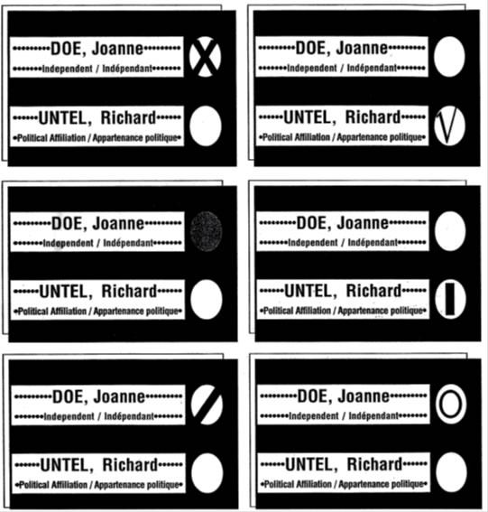
- Mark your ballot correctly! You need to make a mark in the ONE circle next to the name of the candidate you choose. The cross (x) is the most common mark used. Examples of correctly marked ballots:
  - Cross (x)
  - Checkmark
  - Filled circle
  - Straight line
  - Diagonal line
  - Circle

Voting In-Person During COVID-19
Polling stations will look a little different to keep us safe from COVID-19 while voting. This includes:
- Plexi-barriers between voters and poll workers. These are similar to the barriers put between customers and workers at check-out counters in stores.
- Poll workers wearing protective equipment like masks
- Only one worker per table
- Hand sanitizer stations
- Regular cleaning of surfaces that are touched a lot
- Markers to show where you can sit or stand (at least 2 meters or 6 feet apart)

What you can do:
- Wear a mask if you can
If you live in a place where everyone is required to wear a mask, they will also be required at polling stations. If you cannot wear a mask for medical reasons, you will be exempt.
- Bring your own pencil or pen
You will get a single-use pencil to vote if you don’t have one.
- Stay at least 2 meters / 6 feet away from others
- Vote by mail if you face barriers to voting in person or are feeling sick. You will not be allowed to vote in-person if you have symptoms of COVID-19, tested positive for COVID-19, or have been in contact with someone who has COVID-19.

Voting by mail
If you cannot vote in person during the election, you can also vote by mail. Learn more about voting by mail here!
- There are 3 steps:
- Apply to vote by mail
- Get your voting kit in the mail and fill it out
- Mail the voting kit using the pre-paid envelope back to Elections Canada by the deadline
- You should apply as early as you can so there is enough time to receive and send the ballot!
- Voting by mail uses the special ballot process.
- For people living in Canada:
  - To vote by mail, you need to apply on Elections Canada website or at an Elections Canada Office.
  - Deadline:
    - You must apply by Tuesday, September 14, 6:00 PM EST if you apply online outside your riding, or by Tuesday, September 14, 6:00 PM local time if you apply at an Elections Canada office or online inside your riding.
  - You need to provide documentation to prove your identity, either by sending a copy in the mail or uploading a digital image. You need to provide any one of these:
    - 1 piece of government ID OR
    - 2 pieces of ID, both with your name and at least one with your address OR
    - An affidavit, signed before a person authorized to receive oaths in the province or territory, showing your name and home address.

- For people living abroad (outside of Canada):
  - You can apply on Elections Canada Website.
  - Your most recent address in Canada determines your electoral district.
  - You can provide your current address to Elections Canada to receive your ballot by mail.
  - Deadline to apply is Tuesday, September 14, 2021 at 6:00 PM EST.
  - You need to provide documentation to prove your identity, either by sending a copy in the mail or uploading a digital image. You need to provide a copy of any one of these:
    - Pages 2 and 3 of your Canadian passport OR
    - Your Canadian citizenship certificate or card OR
    - Your birth certificate which shows that you were born in Canada.

Voting by mail and COVID-19
- Voting by mail means that you will not have to physically go in-person to a polling place.
- It is a good choice if you are worried about coming into contact with COVID-19 when voting.
- If you are more vulnerable to COVID-19, you should consider voting by mail.
- You will not be allowed to vote in-person if you test positive or have symptoms for COVID-19, or had contact with someone who has COVID-19. That means you can only vote by mail.

Voting information for specific groups
There is information in English and French about voting for:
- Indigenous people
→ français - les autochtones
- Youth
→ français - les jeunes
- Students
→ français - les étudiants
- Canadians abroad (living outside of Canada)
→ français - les Canadiens à l'étranger
- Seniors and disabled people in seniors’ residences and long-term care facilities
→ français - les personnes âgées ou handicapées dans les résidences pour personnes âgées et les établissements de soins de longue durée
- Transgender people
→ français - les personnes transgenres
- New citizens
→ français - les néo-Canadiens
- Disabled people
→ français - les personnes handicapées

Note: Some of these guides are from the 2019 election, and the information may not all apply for the 2021 election. To check on the most updated information, you can contact Elections Canada.

