10. Glossary
All Candidates Meeting: A meeting where all the candidates of an area come together to discuss the issues important to them and the people living in the area. It is also sometimes called a town hall.

Ballot: The paper where you mark your choice of which candidate you would like to be MP for your riding. It has all the names of the candidates for your riding.
It looks like this:
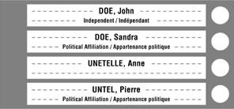
However, if you are voting by special ballot, you will not see a list of candidates on the ballot. Instead, you will see a blank space where you will write the first and last name of the candidate you choose.
Candidate: A person who is trying to get elected.

Elections Canada: The official organization that runs the federal election.

Election day: The main day when people vote. This year, it is Monday, September 20, 2021.

Independent: A candidate or politician that is not part of any political party.
Member of Parliament (MP): MPs are elected officials in the federal House of Commons. They meet in Ottawa to create laws. They also have offices in the areas they represent. Each area (or riding) in Canada will vote for one MP to represent them in the federal House of Commons.

(Political) party: A group of people who have similar ideas and stances on issues. Some of their members are candidates trying to get elected, so that when elected, they can carry out their party’s ideas.
Platform: A party’s or candidate’s platform is the policies and values that they promise to carry out if elected. It tells voters where the party or candidate stands on major issues.
Polling station: The place where you can go to vote.

Riding: Ridings are geographical areas represented by one member of Parliament. Your riding is the one where your home address is. A riding is also called an electoral district. Each riding will select one candidate to be the new MP for that area.

Special ballot: If you are voting by special ballot, you will not see a list of candidates on the ballot. Instead, you will see a blank space where you will write the first and last name of the candidate you choose.

Voter (information) card: If you registered ahead of time, you will receive a voter card by mail that tells you where you can vote. If you bring it with you when you vote, it helps the election workers know that you are registered.

This is what it looks like:
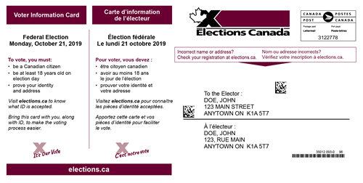
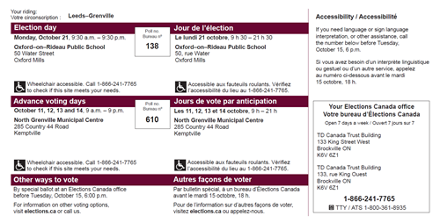
Vouch: To confirm that something is true. If you do not have an acceptable ID or if you are living in a long-term care institution, someone can vouch for your identity and address. See details in the “what you need to bring” section.

The Elections Canada website has a more detailed glossary (not in plain language).

