1. Introduction to the Election

The Federal Government

Types of governments
- There are three levels of government:
  - Municipal (cities, e.g. Vancouver, Toronto)
  - Provincial or territorial (provinces or territories, e.g. British Columbia, Ontario)
  - Federal (the whole country)
- There are also First Nations governments. Band councils govern First Nations communities across the country. They are similar to municipal governments.
- All of these governments have different jurisdictions. This means they are in charge of different issues.
- What is the federal government responsible for?
- The federal government is responsible for issues that affect the whole country such as:
- Mail  - Telephones  - Shipping  - Railways  - Taxes  - Money  - Banking | - Criminal Law  - Pipelines  - Foreign Affairs  - National Defence  - Employment Insurance  - Indigenous Rights and Land
- The federal government also transfers money to the provinces and territories to help them provide services to us. This includes money for things like health care, post-secondary education, social assistance and social services, early childhood development, and child care.

Who is part of the federal government?
- There are three branches (parts) of the government:
  - Legislative (law-making)
  - Executive (decision-making)
  - Judicial (court system)

- The legislative branch is made up of:
  - The monarch, Queen Elizabeth II, represented by the Governor General.
  - The Senate, which is made up of 105 appointed senators. The Governor General chooses senators with the Prime Minister's advice.
  - The House of Commons, which is made up of 338 elected members of Parliament (MPs). Canadian citizens 18 years old and older choose MPs by voting in elections.
  - In the House of Commons, the political party with the most elected MPs forms the Government. Its leader is the Prime Minister.
  - The political party with the second most elected MPs in the House of Commons forms the Official Opposition. Its leader is called the Leader of the Official Opposition.

- The executive branch is made up of:
  - The monarch, again represented by the Governor General.
  - The Prime Minister.
  - The Cabinet, made up of Members of Parliament and sometimes senators invited by the Prime Minister to lead major government departments.
  - Cabinet members are also called Ministers. They include:
- Minister of Finance  - Minister of Health  - Minister of Employment, Workforce Development, and Disability Inclusion  - Minister of Diversity and Inclusion and Youth | - Minister of Environment and Climate Change  - Minister of Families, Children and Social Development  - Minister of Labour  - And more
  - The other main political parties have Shadow Cabinets. Their leaders appoint MPs in their party to be Shadow Cabinet members. Shadow Cabinet members are also called critics.
  - Critics are responsible for similar areas as the Government’s Cabinet (e.g. Critic for Health, Critic for Finance). They analyze whether the Government’s policies and actions in these areas are good or bad, and suggest different policies.
- The judicial branch is made up of courts that interpret the laws created by the other two branches.
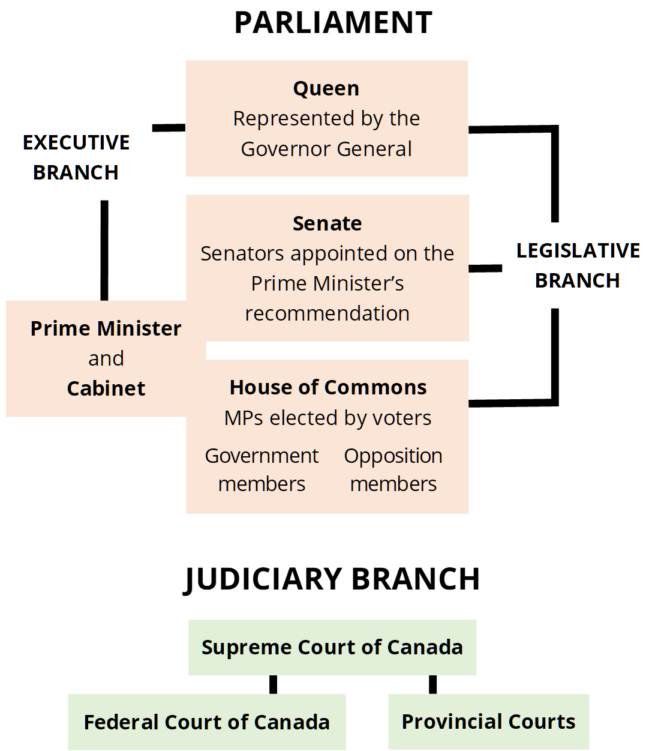
Adapted from the Parliament of Canada’s Parliamentary System guide

The Federal Election

What is the federal election?
- The federal election is how we choose Members of Parliament (MPs) to represent us in the government.
- This is done through a secret ballot vote. This means every voter's choice is kept anonymous, which means that no one will know you voted for unless you tell them.

How often does the election happen?
- By law, the federal election must happen every four years on the third Monday in October.
- However, the Prime Minister can advise the Governor General to dissolve the government and call an election at an earlier time.

What are we voting for?
- You are voting for a Member of Parliament (MP).
  - MPs are elected officials in the federal House of Commons. They meet in Ottawa to create laws. They also have offices in the areas they represent.
  - The people trying to get elected are called candidates.
  - Each area (or riding) in Canada will vote for one MP to represent them in the federal House of Commons.

- You are also voting for the Prime Minister of Canada.
  - The Prime Minister is the leader of the political party that has the most candidates elected.
    - For example, if Party 1 elects 200 candidates, Party 2 elects, 100 candidates, and Party 3 elects 38 candidates, Party 1 will have won the election.
  - You do not vote for a Prime Minister directly (unless he/she/they is also a candidate in your riding).
  - When you vote for a candidate of a certain party, you are also supporting the leader of that party to become Prime Minister.

Who are the parties and candidates?
- The four main parties are the New Democratic Party, the Liberal Party, the Conservative Party, and the Green Party.

NDP Party Leader: Jagmeet Singh
Liberal Party Leader: Justin Trudeau
Conservative Party Leader: Erin O’Toole
Green Party Leader: Annamie Paul
- Here is a full list of parties in the upcoming election.
- Here is a full list of candidates in the upcoming election.
- Some candidates are not in any party, and are called independents.
- Note that not all ridings include a Green candidate.

What are ridings?
- Ridings are geographical areas represented by one MP. Your riding is the one where your home address is.
- A riding is also called an electoral district.
- Each riding will select one candidate to be the new MP for that area.
- You can look up which candidates are running for election in your riding using the Elections Canada tool here.

How do candidates get elected?
- Canada’s electoral system is a “single-member plurality” system. It is often called the “first-past-the-post” system.
- This means that, in every riding, the candidate with the most votes wins a seat in the House of Commons and becomes the MP that represents that riding.

- This is a “winner takes all” approach. There does not need to be an absolute majority (more than 50% of the votes) for a candidate to become the new MP.
  - Example: Candidates A, B, C, and D are all running to become the new MP in a riding.
Candidate | Number of Votes
Candidate A | 16
Candidate B | 24
Candidate C | 32
Candidate D | 15

  - In this case, Candidate C will win the seat and become the MP because they have the most votes.

- The party who wins the most seats across Canada wins the election. They become the government.
  - If they have more than 50% of the seats in the House of Commons, they will form a majority government.
  - If they have less than 50%, they will form a minority government.
- Sometimes if the count is really close, a judicial recount may be ordered, where the ballots are counted again.

To Learn More
- How Government Works (Government of Canada)
- Learn About Parliament (Parliament of Canada)
- The Electoral System of Canada (Elections Canada)
- Your Canadian Federal Election Glossary (CBC)
Note: This guide is from the 2019 Election, but the terms are similar

