#AutisticsVote Federal Election Toolkit 2021
An Autistic Advocacy Guide to Voting and the Election

Introduction
The 2021 federal election in Canada is happening on Monday, September 20th.

Our #AutisticsVote Toolkit is a guide to help autistic people vote in the federal election and advocate on issues that affect our community.

We made this toolkit to help autistics and allies:
- Understand how the electoral system and voting process works
- Talk about issues that affect autistic people with friends, family, social media networks, and federal candidates

We know that our community is diverse and that autistic people often have trouble voting because of many reasons.

This may be because we have many disabilities, are women, are 2SLGBTQIA+ (Two-Spirit, lesbian, gay, bisexual, transgender, queer, intersex, asexual/aromantic), are BIPOC (Black, Indigenous and/or people of colour), are poor, are living on the streets, or are part of any other group that has more trouble voting because of barriers that the election system creates.

In this toolkit, we have included links to resources for Deaf and Hard of Hearing people, people with physical disabilities, people with cognitive disabilities, non-native speakers of English or French, and youth. We have tried to make the toolkit as plain language as possible. There is alt-text for all images.

Downloads
You can download this #AutisticsVote Toolkit in Microsoft Word or PDF format on our website. You can download individual sections or the whole toolkit. Download here: bit.ly/AutisticsVote
You may also find our Talking to Your MP About Autistic Self-Advocacy guide helpful too. It is also available in Microsoft Word or PDF format on our website. Download here: bit.ly/TalkingToMPs
Note: The Talking to Your MP About Autistic Self-Advocacy guide was created before the COVID-19 pandemic. It talks about in-person meetings that may not apply in your area.
Questions?
If you have any questions or suggestions about the toolkit, please contact us at info@AutisticsUnitedCA.org.
Official Elections Information
Elections Canada is the official place to get information about voting at the 2021 federal election. Visit their website (English version / version française), and find updates on Twitter (English version / version française) or Facebook.

Elections Canada also has a guide to the 2021 Federal Election. It is available in English, French and several other languages.
Spread the Word
Join the conversation on social media! Use the hashtags #elxn44, #AutisticsVote and #cdnpoli when posting about the election.
Autistics United Canada is a national autistic-led advocacy organization. We are a grassroots collective of autistic youth and adults in what is colonially known as Canada. We have provincial chapters and local hubs, and a network of autistic advocates and allies across the country.

All our organizing collective members are autistic people. This is because we value “Nothing About Us, Without Us!” From local initiatives to international issues, we build community, promote disability justice, foster pride and acceptance, and advocate for a better world for all autistic people. To learn more about us, visit AutisticsUnitedCA.org.

Table of Contents
1. Introduction to the Election
The Federal Government
Types of governments
What is the federal government responsible for?
Who is part of the federal government?
The Federal Election
What is the federal election?
How often does the election happen?
What are we voting for?
Who are the parties and candidates?
What are ridings?
How do candidates get elected?
To Learn More
2. How to Contact Candidates
Find Candidate Contact Information
Contact the candidates in your riding
Contact the federal parties and leaders
Contact other candidates
3. Email Template
4. Questions to Ask Your Candidates
Autistic Consultation - Nothing About Us Without Us!
Healthcare
Violence towards Autistic People
Stigma vs. Acceptance
Equitable and Affordable Housing
Poverty and Employment
Communication Access
Research
Beyond the Accessible Canada Act
5. How to Find Out More About Policy Issues and Candidates
6. How to Get More Involved
7. How to Vote
Requirements to Vote
Who can vote?
What you need to bring
Registering to Vote
Do I have to register to vote?
How do I register to vote?
Different Ways to Vote
Voting in person
Finding your polling station
What happens when you vote at your assigned polling station
Voting In-Person During COVID-19
Voting by mail
Voting by mail and COVID-19
Voting information for specific groups
8. Accessible Voting
Building Accessibility
What is an “accessible” polling station?
How do I check if my polling station is accessible?
Voting Tools and Services
How do I give feedback on my polling station’s accessibility?
Information for People with Sensory Sensitivities
Getting to the Polling Station
Additional Accessibility Resources
9. COVID-19 Safety While Voting
10. Glossary

1. Introduction to the Election

The Federal Government

Types of governments
- There are three levels of government:
  - Municipal (cities, e.g. Vancouver, Toronto)
  - Provincial or territorial (provinces or territories, e.g. British Columbia, Ontario)
  - Federal (the whole country)
- There are also First Nations governments. Band councils govern First Nations communities across the country. They are similar to municipal governments.
- All of these governments have different jurisdictions. This means they are in charge of different issues.

What is the federal government responsible for?
- The federal government is responsible for issues that affect the whole country such as:
- Mail  - Telephones  - Shipping  - Railways  - Taxes  - Money  - Banking | - Criminal Law  - Pipelines  - Foreign Affairs  - National Defence  - Employment Insurance  - Indigenous Rights and Land

- The federal government also transfers money to the provinces and territories to help them provide services to us. This includes money for things like health care, post-secondary education, social assistance and social services, early childhood development, and child care.

Who is part of the federal government?
- There are three branches (parts) of the government:
  - Legislative (law-making)
  - Executive (decision-making)
  - Judicial (court system)

- The legislative branch is made up of:
  - The monarch, Queen Elizabeth II, represented by the Governor General.
  - The Senate, which is made up of 105 appointed senators. The Governor General chooses senators with the Prime Minister's advice.
  - The House of Commons, which is made up of 338 elected members of Parliament (MPs). Canadian citizens 18 years old and older choose MPs by voting in elections.
  - In the House of Commons, the political party with the most elected MPs forms the Government. Its leader is the Prime Minister.
  - The political party with the second most elected MPs in the House of Commons forms the Official Opposition. Its leader is called the Leader of the Official Opposition.
- The executive branch is made up of:
  - The monarch, again represented by the Governor General.
  - The Prime Minister.
  - The Cabinet, made up of Members of Parliament and sometimes senators invited by the Prime Minister to lead major government departments.
  - Cabinet members are also called Ministers. They include:
- Minister of Finance  - Minister of Health  - Minister of Employment, Workforce Development, and Disability Inclusion  - Minister of Diversity and Inclusion and Youth | - Minister of Environment and Climate Change  - Minister of Families, Children and Social Development  - Minister of Labour  - And more

  - The other main political parties have Shadow Cabinets. Their leaders appoint MPs in their party to be Shadow Cabinet members. Shadow Cabinet members are also called critics.
  - Critics are responsible for similar areas as the Government’s Cabinet (e.g. Critic for Health, Critic for Finance). They analyze whether the Government’s policies and actions in these areas are good or bad, and suggest different policies.
- The judicial branch is made up of courts that interpret the laws created by the other two branches.

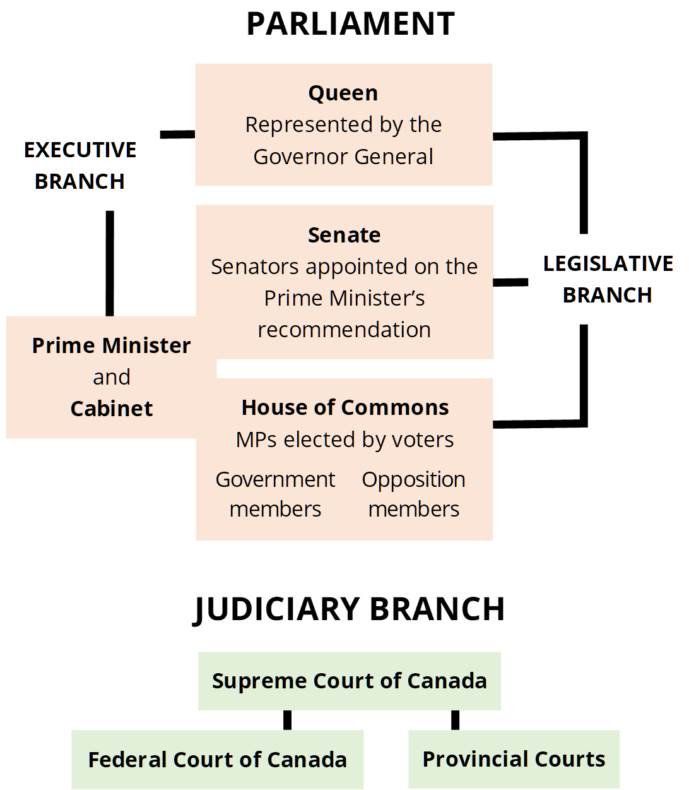
Adapted from the Parliament of Canada’s Parliamentary System guide

The Federal Election

What is the federal election?
- The federal election is how we choose Members of Parliament (MPs) to represent us in the government.
- This is done through a secret ballot vote. This means every voter's choice is kept anonymous, which means that no one will know you voted for unless you tell them.

How often does the election happen?
- By law, the federal election must happen every four years on the third Monday in October.
- However, the Prime Minister can advise the Governor General to dissolve the government and call an election at an earlier time.

What are we voting for?
- You are voting for a Member of Parliament (MP).
  - MPs are elected officials in the federal House of Commons. They meet in Ottawa to create laws. They also have offices in the areas they represent.
  - The people trying to get elected are called candidates.
  - Each area (or riding) in Canada will vote for one MP to represent them in the federal House of Commons.

- You are also voting for the Prime Minister of Canada.
  - The Prime Minister is the leader of the political party that has the most candidates elected.
    - For example, if Party 1 elects 200 candidates, Party 2 elects 100 candidates, and Party 3 elects 38 candidates, Party 1 will have won the election.
  - You do not vote for a Prime Minister directly (unless he/she/they is also a candidate in your riding).
  - When you vote for a candidate of a certain party, you are also supporting the leader of that party to become Prime Minister.

Who are the parties and candidates?
- The four main parties are the New Democratic Party, the Liberal Party, the Conservative Party, and the Green Party.

NDP Party Leader: Jagmeet Singh
Liberal Party Leader: Justin Trudeau
Conservative Party Leader: Erin O’Toole
Green Party Leader: Annamie Paul
- Here is a full list of parties in the upcoming election.
- Here is a full list of candidates in the upcoming election.
- Some candidates are not in any party, and are called independents.
- Note that not all ridings include a Green candidate.

What are ridings?
- Ridings are geographical areas represented by one MP. Your riding is the one where your home address is.
- A riding is also called an electoral district.
- Each riding will select one candidate to be the new MP for that area.
- You can look up which candidates are running for election in your riding using the Elections Canada tool here.

How do candidates get elected?
- Canada’s electoral system is a “single-member plurality” system. It is often called the “first-past-the-post” system.
- This means that, in every riding, the candidate with the most votes wins a seat in the House of Commons and becomes the MP that represents that riding.
- This is a “winner takes all” approach. There does not need to be an absolute majority (more than 50% of the votes) for a candidate to become the new MP.
  - Example: Candidates A, B, C, and D are all running to become the new MP in a riding.
Candidate | Number of Votes
Candidate A | 16
Candidate B | 24
Candidate C | 32
Candidate D | 15

  - In this case, Candidate C will win the seat and become the MP because they have the most votes.

- The party who wins the most seats across Canada wins the election. They become the government.
  - If they have more than 50% of the seats in the House of Commons, they will form a majority government.
  - If they have less than 50%, they will form a minority government.

- Sometimes if the count is really close, a judicial recount may be ordered, where the ballots are counted again.

To Learn More
- How Government Works (Government of Canada)
- Learn About Parliament (Parliament of Canada)
- The Electoral System of Canada (Elections Canada)
- Your Canadian Federal Election Glossary (CBC)
Note: This guide is from the 2019 Election, but the terms are similar

2. How to Contact Candidates

Find Candidate Contact Information

Contact the candidates in your riding:
- Go to the Elections Canada tool here.
- Type in your postal code in the box for "Search by postal code".
- Click "Search".
- Click "Who are the candidates in my electoral district?"
- Click on the links to the candidates' websites.
- Contact page: The websites may have a "contact" page with a contact form and contact information.
- Email: Most of the time email addresses are at the top or bottom, or on the contact page of the website.
- Phone: Phone numbers are often listed at the top, bottom, or on the contact page of the websites. If you phone before or after the office opening hours, you may be able to just leave a voicemail.
- Social media: You can also contact the candidates through their social media accounts, listed on their website. E.g. Facebook, Twitter, Instagram, TikTok

Contact the federal parties and leaders:
- Liberal Party contact page
- New Democratic Party contact page
- Jagmeet Singh contact info (scroll to bottom)
- Conservative Party contact page
- Erin O’Toole contact info (scroll to bottom)
- Green Party contact page
- Annamie Paul contact info (scroll to bottom)

Contact other candidates:
- Go to the Elections Canada tool here.
- Follow the instructions at the bottom to do different types of searches:
  - by postal code
  - by electoral district name
  - by candidate name
  - by maps
  - by place name (village, city)
  - by list (all of Canada or by province)
- Visit the candidate website to find more about how to contact them.
- Tip: You can try contacting existing Cabinet ministers and Shadow Cabinet critics if they are running for election again, and ask about issues that are under their responsibility.
  - List of government (Liberal Party) Cabinet ministers
  - List of NDP Shadow Cabinet critics
  - List of Green Party Shadow Cabinet critics
  - List of Conservative Party Shadow Cabinet critics
  - After you find out the name of the candidate you want to contact, use the above steps 1-3 to find out if they are running for re-election and find contact information.

3. Email Template
Here is a template email letter that you can write to candidates.

Let's get the candidates to commit to supporting autistic and otherwise disabled people!

When sending the email, make sure to add the name of the MP at the top, and your own name and postal address at the bottom.

You can also change the template to personalize it.

Subject: Your Commitments to Autistic and Disabled People in Canada

Dear Mr./Ms./Mx. ______,

I am writing to you as a member of your constituency, and as a member of Autistics United Canada, a grassroots collective of autistic youth and adults across the country. As one of the few entirely autistic-led organizations in Canada, representing thousands of members, we would like to ask about your party’s commitments to improving the lives of autistic people.

1. Autistic people and otherwise disabled and neurodivergent people face violence, discrimination, and human rights violations daily, at school, work, home, institutions, and healthcare settings. What is your party committing to do to protect the rights, well-being, and safety of autistic and otherwise neurodivergent/disabled people?

2. Will your party commit to meaningfully consulting directly with autistic people of diverse backgrounds and autistic-led organizations whenever creating national autism and disability policy, in accordance with United Nations Convention on the Rights of Persons with Disabilities and General comment No. 7 (2018) on the participation of persons with disabilities?

3. Canada ranks second last in health care among high-income countries (Schneider et al., 2021). The lack of universal pharma care, vision care, and dental care have been identified as concerns. Will your party implement a universal, single-payer public pharma care, vision, and dental care system? If elected, when will this happen?

4. Autistic people have protested harmful interventions for decades. Applied Behaviour Analysis, a costly intervention, has been widely reported to cause long-term trauma, maladaptive compliance, and vulnerability to abuse (Brown, 2014; Dawson & Fletcher-Watson, 2020; Gardner, 2017; Milton, 2018; Sandoval-Norton & Shkedy, 2019; Wilkenfeld & McCarthy, 2020). ABA has historical and ongoing links to gay and gender-non-conforming conversion therapy, which the federal government has already moved to ban (Pyne, 2020). As well, pseudoscience "cures" for autism are still marketed in Canada and sold by Canadian health care providers (Lindsay, 2020; Weeks, 2019).

Will your party resolve to take stronger measures to ban harmful "treatments" for autism such as Applied Behavioural Analysis, Miracle Mineral Solution, chelation, and fecal matter transplant therapy, and fund neurodiversity-affirming, trauma-informed supports created with autistic consultation in their place? If so, when can we expect this to happen?

5. To ensure that all disabled people have access to safe, affordable, and accessible housing, will your party commit to desegregate housing by closing institutions and re-routing funding towards independent supported living, and funding more than the inadequate 20% new accessible housing targeted in the National Housing Strategy? If elected, what targets will your party commit to and when can we expect they will be achieved?

6. Augmentative and Alternative Communication (AAC) users, including those newly hospitalized during the pandemic and requiring assistive technology, face significant barriers due to inaffordability and maltreatment by school and health care providers (Ganz, 2015; Lindsay, 2010; McQuigge, 2020). Will your party commit to funding affordable early access to AAC and creating a national education program led and informed by AAC users to train health care providers, educators, and other professionals working with autistic and otherwise AAC-using people?

7. While Canadians receiving CERB received up to $38,000, the support offered to disabled people was a mere $600 one-time payment to Disability Tax Credit recipients. Is your party committed to reforming the benefits system such as the DTC and reducing poverty among disabled people in Canada? Will your party commit to working alongside provincial and territorial governments and Indigenous peoples to create a universal guaranteed basic income program? If elected, how and when would your party plan to implement reforms?
8. The passage of Bill C-7 in March 2021 dramatically expanded eligibility for Medical Assistance in Dying to include disabled people not near end-of-life. Human rights and disability justice experts and UN officials have warned that this expansion discriminates against disabled people and lacks adequate safeguards. We are gravely concerned about how disabled people, particularly people with intellectual and developmental disabilities, disabled BIPOC, disabled people in poverty, and other multiply marginalized disabled people, are being coerced and pressured to receive MAiD due to systemic inequities, extreme lack of critical health care, supports and services, and ableist institutional bias.
Will your party commit to reforming MAiD legislation to align with Article 6 and 26 of the UN ICCPR and the Vulnerable Persons Standard, by:
1) restoring more stringent safeguards to protect those vulnerable to coercion?
2) implementing safeguards that disabled people who request MAiD are guaranteed meaningful, timely alternatives to access disability services and supports?
3) collecting and publicly reporting comprehensive data about MAiD (including disaggregated demographic data) to assess whether Canada’s safeguards are adequate?
4) meaningfully involving and actively addressing the concerns of diverse groups of disabled people, especially multiply marginalized disabled people in any review or changes to MAiD?
9. Disabled and neurodivergent children and their families do not have access to affordable, inclusive child care support. This disproportionately impacts disabled parents, who also face institutional ableism and lack of supports that sanction the removal of their children from their care. Will your party commit to funding affordable, inclusive, neurodiversity-affirming childcare and protecting the rights of disabled parents to keep and raise their own children?
Thank you for your time and consideration. I look forward to hearing your response.

Sincerely,
[your name]
[your postal code]

4. Questions to Ask Your Candidates
These are questions on federal issues that affect autistic people. You will not have time to ask all of them to a candidate, but you can choose the ones that mean the most to you.

Autistic Consultation - Nothing About Us Without Us!
- Will your party commit to meaningfully consulting with autistic-led organizations and autistic people of diverse backgrounds whenever creating national autism and disability policy?
This means that the party will talk to many different autistic people, such as autistic people who are BIPOC, women, 2SLGBTQIA+, non-speaking, AAC-using, houseless, and/or requiring significant supports. The party must actively work with autistic people, and make sure autistic people’s ideas and perspectives are followed through.

Health Care and Child Care
- Will your party implement a universal, single-payer public pharmacare system? This means that prescription medications will be funded by the government.

- Will your party ensure that the national mental health strategy will provide accessible, affordable, and diverse mental health support options for disabled and neurodivergent people?
- Will your party commit to defund and ban harmful “therapies” for autism, including Applied Behavioural Analysis and pseudoscience “cures”? Will your party commit to funding neurodiversity-affirming, trauma-informed supports and services created by and in consultation with autistic people instead?
- Will your party commit to implementing the full meaning and scope of Jordan’s Principle to make sure First Nations children have equitable access to government services?"
- Will your party commit to funding affordable, inclusive, neurodiversity-affirming child care and protecting the rights of disabled parents to keep and raise their own children?

Violence towards Autistic and Otherwise Disabled People
- Will your party commit to defunding police and prisons, and instead fund community-based services that address the roots of violence (e.g. mental health, housing, education, transportation, financial, & child and family supports)?

- Will your party commit to working with provincial and territorial governments to ban seclusion and restraint in schools, strengthen reporting and accountability requirements, and provide trauma-informed conflict and de-escalation training for school staff?

- Will your party resolve to take stronger measures to crack down on deadly non-evidenced “treatments” for autism such as Miracle Mineral Solution and chelation?

- Will your party commit to reforming Medical Assistance in Dying legislation to align with Article 6 and 26 of the UN ICCPR and the Vulnerable Persons Standard, by:
1) restoring more stringent safeguards to protect those vulnerable to coercion?
2) implementing safeguards that disabled people who request MAiD are guaranteed meaningful, timely alternatives to access disability services and supports?
3) collecting and publicly reporting comprehensive data about MAiD (including disaggregated demographic data) to assess whether Canada’s safeguards are adequate?
4) meaningfully involving and actively addressing the concerns of diverse groups of disabled people, especially multiply marginalized disabled people in any review or changes to MAiD?

Stigma vs. Acceptance
- Will your party resolve to end stigma towards autism, stop harmful awareness campaigns that further stigmatize autistic people, and work with autistic people to instead promote autism acceptance?

Equitable and Affordable Housing
- Will your party fund affordable and accessible housing using Housing First strategies for people of all disabilities?

- Will your party adopt legislation to protect the right to independent supported living?

- Will your party commit to desegregated housing by closing institutions and re-routing funding towards independent supported living?
- Will your party commit to a target larger than merely 20% of new accessible housing in the National Housing Strategy?

Poverty and Employment
- Will your party reform the Disability Tax Credit: expanding eligibility, improving transparency of approval process and criteria, ending clawbacks, and simplifying application forms and processes?
- Will your party commit to working alongside provincial and territorial governments and Indigenous peoples to create a universal guaranteed basic income program?
- Will your party work with autistic people to adopt more equitable hiring practices?

- Will your party work alongside provincial and territorial governments to end sheltered workshops and instead transition disabled people to competitive integrated employment?

Communication Access
- Will your party adopt a Communication Bill of Rights, enshrining the specific rights of those facing communication barriers, to guide legislation and government programs?
- Will your party commit to working with provincial and territorial governments to fund affordable early access to Augmentative and Alternative Communication (AAC)?
- Will your party work with AAC users to create a national education program for health care providers, educators, and other professionals working with autistic and otherwise AAC-using people?

- Will your party commit to providing plain language and accessible format versions of all legislation, policies, and services that impact people with disabilities?

Research
- Will your party invest in programs that fund participatory autism research that requires autistic co-design, consultation and input?

- Will your party invest in research on supports rather than cures, such as AAC supports, integrated employment supports, supports in educational settings, and autistic burnout and mental health?

Beyond the Accessible Canada Act

- Will your party commit to creating a national disability strategy with consultation of diverse disabled people, including autistic people?

- Will your party commit to collecting independent, disaggregated demographic data on autistic people’s social and economic status, including income, employment, education, incarceration, housing, mental and physical health, access to basic needs, and access to assistive devices, supports, and services?

5. How to Find Out More About Policy Issues and Candidates
- Visit the websites of the major political parties:
  - Liberal Party of Canada
  - New Democratic Party (NDP) of Canada
  - Green Party of Canada
  - Conservative Party of Canada
- Read the party platforms:
  - All political parties release a platform before the election.
  - A party’s platform is the policies and values that it promises to make happen if elected. It tells voters where the party stands on major issues.
  - You can read the platforms on each party’s website.
  - Here are platforms on disability issues by:
    - The Liberal Party (page 96)
    - The New Democratic Party (NDP)
    - The Conservative Party (page 68)
    - The Green Party (page 77)
- Read, listen, or watch the news coverage of the election:
  - You can find updates about the election on the TV news, radio stations, and print and online newspapers.
  - For example, news media will have summaries of party platforms. These are some news sites that we found as examples, but this is not a full list:
    - CBC
    - Maclean’s
    - CTV News
    - The Globe and Mail (note: You must create an account to access this page)
    - The National Post
  - Note: All news media have their own bias and perspective. When reading articles in the news about candidates, parties, and their platforms, keep in mind that journalists summarize and paraphrase what they think is important.

- Attend or watch a debate:
  - Televised Federal Leaders’ debates
    - There are two organized by the Leaders' Debates. They have already happened, but you can watch them online here:
      - English Leaders Debate
      - French Leaders Debate
      - The debates are aired on major television networks. Full videos can be found online on news media websites afterwards.
      - CBC has more information about how to watch the debates.
    - News media will also have articles talking about the Leaders’ debates and fact checking them. Fact checking means looking into what someone says and double checking if they are telling the truth or not.

  - Local town halls (also called All Candidates Debates)
    - You can find where and when your all-candidates debates are by searching “[your riding’s name (e.g. Vancouver South], all candidates debate”
    - They may also be listed in local newspapers.
    - Many debates will be held online this year because of COVID-19.
    - If you miss an all candidates debate, you can see if it was recorded and can be watched online.
  - This year, a group of disability organizations hosted a All-Parties Candidates Debate on Disability Issues. You can watch it by clicking here.

- Visit the websites and social media of the candidates in your riding:
  - You can do this by looking up the candidate’s name. Find out who is running for MP in your riding using the Elections Canada tool here.
  - If one of the candidates is currently an MP, find out how they have talked about and voted on issues in Parliament in the past.
  - Some resources for finding this out are:
    - The Parliament of Canada website: https://www.ourcommons.ca/en
    - Open Parliament, an independent website: https://openparliament.ca/

- Check the facts:
  - Not everything that a political candidate or party says is true. Sometimes they lie or say misleading things.
  - Do research to check if what they are saying is true. Make sure you check that your sources are credible and reliable.
  - News media will sometimes do fact checks.

6. How to Get More Involved
- Reach out and talk to the candidates! Check out our guide to Talking to MPs about Autistic Self-Advocacy for more tips.
  - Note: This guide was created before the COVID-19 pandemic. Some of the tips for in-person meetings may not apply anymore as procedures changed.
- During elections, candidates often have “Meet and Greet” events, where you may be able to ask them questions. During the pandemic, many of these will be online.
  - For a list of questions, see the “Questions to Ask Candidates” section of this toolkit.
  - You can ask your candidate questions on any issue.

- You can also ask questions during Town Hall debates. There can be different ways to ask questions depending on the debate:
  - Online via Zoom or other video conferencing
  - Through a mobile device app
  - Through an online form
  - If in person, sometimes by writing your question on a piece of paper and giving it to a volunteer or worker.
  - If you ask a question during a debate, it may not get answered depending how many questions are asked. Candidates often stay behind afterwards if you want to speak to them one-on-one and ask questions.

- Phone or email your candidates to ask them questions and learn more about them.

- Visit the candidate’s office to see how they are running the campaign and meet the volunteers and staff.

- Ask questions on your candidates’ social media pages (e.g. Facebook, Twitter, Instagram, TikTok). Some candidates use social media more than other candidates.

- Write letters to the candidates and newspapers about issues that matter to you. See the “How to Contact Candidates'' section of this toolkit for more information. Candidates have an email address and office address you can send electronic or written mail to. You can also contact them on their social media pages. Newspapers will have a page on their websites where you can submit Letters to the Editor.

- Join the conversation online. There are hashtags used on social media when people talk about Canadian politics and the upcoming election:
  - #Cdnpoli
  - #Canpoli
  - #elxn44

- Talk to family and/or friends you trust about how voting works. Encourage and support each other to vote!

- Practice voting by using a practice ballot to roleplay with. You can phone or email Elections Canada to ask them to send you a kit. Elections Canada also has teaching resources on the Elections and Democracy website, including printable resources.

- Volunteer for or donate to a candidate that you support. You can find volunteer opportunities by visiting the candidate’s website or contacting their campaign office.

- Apply to work for the election. There are many jobs available.

7. How to Vote

Requirements to Vote

Who can vote?
- You must be a Canadian citizen
- You must be at least 18 years old on election day
- You must provide proof of your identity and address

What you need to bring
To vote, you need to bring an ID or another way to prove your identity and address.

- Option 1: A valid piece of photo ID
Examples:
  - Driver’s license
  - Any other photo ID issued by the government (federal, provincial/territorial, or local), with your photo, name and current address

- Option 2: two pieces of ID, both with your name, and at least one with your address
Examples:
  - Voter information card and bank statement
  - Utility bill and student ID card
  - The Elections Canada website has a full list of accepted ID (available in other languages and printable format).

- Option 3: A person who can vouch for your identity and address
  - Vouching means someone else saying on your behalf that you are eligible to vote.
  - The person who vouches for you must be an eligible voter assigned to the same polling station as you. They can only vouch for one person.
  - If you are in a senior’s residence, group home, or other long-term care institution, an employee at the institution can vouch for you. They can vouch for more than one person.

- COVID-19 Safety:
  - Bring a mask if you can wear one
  - You can bring your own pencil or pen

Registering to Vote

Do I have to register to vote?
- Yes, you have to register to vote.
- You can register ahead of time, before you go to vote.
- You can also register at the polling station, when you go to vote either on advance polling/voting days or on election day. You will have assigned polling stations depending on where you live. This will be a place in your neighbourhood where you can go to vote.
- Try to register early, as lines during voting days can get long!

How do I register to vote?
- Option 1: Before you go to vote
  - Use the Online Voter Registration Service by Tuesday, September 14 at 6 p.m.
  - Or go in person at any Elections Canada office by Tuesday, September 14 at 6 pm.
  - If you register before you go to vote, you will receive a voter information card in the mail that will tell you your assigned polling station (where you go to vote).

- Option 2: When you go to vote
- At your assigned polling station on election day, Monday, September 20.
- At your assigned polling station on advance polling days:
  - Friday, September 10
  - Saturday, September 11
  - Sunday, September 12
  - Monday, September 13
- At any Elections Canada office across Canada before Tuesday, September 14 at 6 pm.
- You will register by bringing your ID or a person to vouch for you.
- Assigned polling stations are places where you can vote depending on where you live. See the “Finding your polling station” section of this toolkit for more information.
For more information, see Elections Canada registration FAQs.

Different Ways to Vote
You can vote in person at different times and locations, or you can vote by mail.

There is also information in English and French for Indigenous people, youth, students, Canadians abroad, seniors and disabled people in seniors’ residences and long-term care facilities, transgender people, new citizens, and disabled people on how to vote.

Because of the COVID-19 pandemic, voting may look a bit different than before. Polling stations will have safety measures in place. Voting by mail should be similar to before but more people will use this option than in the past.

Elections Canada has more information on voting during COVID-19.

Voting in person
- When to Vote:
- On election day at your assigned polling station
  - Monday, September 20
  - Polls are open for 12 hours
  - Click here to find out when the polls are open in your time zone
- Before election day at your assigned polling station from 9 AM to 9 PM on the following days:
  - Friday, September 10
  - Saturday, September 11
  - Sunday, September 12
  - Monday, September 13
- At any Elections Canada Office:
  - There are more than 500 election offices.
  - The deadline to vote at an Elections Office is September 14th, at 6:00 PM local time.
  - NOTE: Voting at an Elections Canada Office is different from voting on election day or at advance polling stations. You will use the Special Ballot Process. You will write down the candidate’s name on the ballot. You can ask to see a list of candidate names for your riding.
  - Here is a video with a transcript from Elections Canada about voting at an Elections Canada office (ASL version).

Finding your polling station
  - A polling station is a place where voting happens during an election.
  - Examples of places that may be used as polling stations include:
    - Schools
    - Community centres
    - Common areas in apartment buildings
  - If you registered early, your polling stations (for both advanced voting and voting on election day) will be on the voter’s card that you receive in the mail.
  - Your polling station may be different during advanced voting than voting on election day.

  - To find your assigned polling station online, go to the Voter Information Service website:
- Put in your postal code next to “Search by postal code”
- Click “Search”
- Click “Where do I vote?”
- The website will tell you where and when you can vote on election day (Sept. 20) or on advance polling/voting days (Sept. 10-13). The location can be the same or different for these two options, depending on where you live.
  - There may be one than one polling station for your postal code. If this happens, you will see a page asking you to enter your full address instead.
  - If you do not know your postal code, you can find out on the Canada Post website.

What happens when you vote at your assigned polling station
- You will be greeted by a worker, who will show you to the right table, where another worker will assist you.
- You will be asked to prove your identity and address.
- The worker will give you a folded ballot.
- You will go behind a voting screen to vote.
- Mark and refold your ballot to keep it secret.
- After voting, give your ballot to an elections worker, who will tear off the tab.
- Put your ballot in the ballot box.

- For more information on how to vote you can visit Election Canada’s website for a video with a transcript (ASL version).
Note: These videos were for the 2019 Election. Voting this year will be pretty similar, but there may be some differences because of COVID-19. Learn more by clicking here.

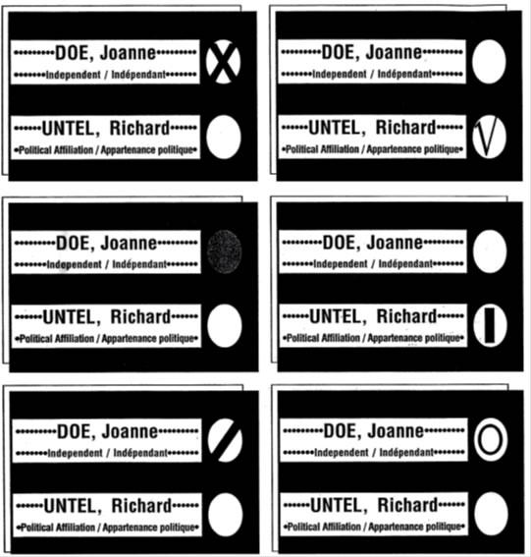
- Mark your ballot correctly! You need to make a mark in the ONE circle next to the name of the candidate you choose. The cross (x) is the most common mark used. Examples of correctly marked ballots:
  - Cross (x)
  - Checkmark
  - Filled circle
  - Straight line
  - Diagonal line
  - Circle

Voting In-Person During COVID-19
Polling stations will look a little different to keep us safe from COVID-19 while voting. This includes:
- Plexi-barriers between voters and poll workers. These are similar to the barriers put between customers and workers at check-out counters in stores.
- Poll workers wearing protective equipment like masks
- Only one worker per table
- Hand sanitizer stations
- Regular cleaning of surfaces that are touched a lot
- Markers to show where you can sit or stand (at least 2 meters or 6 feet apart)

What you can do:
- Wear a mask if you can
If you live in a place where everyone is required to wear a mask, they will also be required at polling stations. If you cannot wear a mask for medical reasons, you will be exempt.
- Bring your own pencil or pen
You will get a single-use pencil to vote if you don’t have one.
- Stay at least 2 meters / 6 feet away from others
- Vote by mail if you face barriers to voting in person or are feeling sick. You will not be allowed to vote in-person if you have symptoms of COVID-19, tested positive for COVID-19, or have been in contact with someone who has COVID-19.

Voting by mail
If you cannot vote in person during the election, you can also vote by mail. Learn more about voting by mail here!
- There are 3 steps:
- Apply to vote by mail
- Get your voting kit in the mail and fill it out
- Mail the voting kit using the pre-paid envelope back to Elections Canada by the deadline
- You should apply as early as you can so there is enough time to receive and send the ballot!
- Voting by mail uses the special ballot process.
- For people living in Canada:
  - To vote by mail, you need to apply on Elections Canada website or at an Elections Canada Office.
  - Deadline:
    - You must apply by Tuesday, September 14, 6:00 PM EST if you apply online outside your riding, or by Tuesday, September 14, 6:00 PM local time if you apply at an Elections Canada office or online inside your riding.
  - You need to provide documentation to prove your identity, either by sending a copy in the mail or uploading a digital image. You need to provide any one of these:
    - 1 piece of government ID OR
    - 2 pieces of ID, both with your name and at least one with your address OR
    - An affidavit, signed before a person authorized to receive oaths in the province or territory, showing your name and home address.

- For people living abroad (outside of Canada):
  - You can apply on Elections Canada Website.
  - Your most recent address in Canada determines your electoral district.
  - You can provide your current address to Elections Canada to receive your ballot by mail.
  - Deadline to apply is Tuesday, September 14, 2021 at 6:00 PM EST.
  - You need to provide documentation to prove your identity, either by sending a copy in the mail or uploading a digital image. You need to provide a copy of any one of these:
    - Pages 2 and 3 of your Canadian passport OR
    - Your Canadian citizenship certificate or card OR
    - Your birth certificate which shows that you were born in Canada.

Voting by mail and COVID-19
- Voting by mail means that you will not have to physically go in-person to a polling place.
- It is a good choice if you are worried about coming into contact with COVID-19 when voting.
- If you are more vulnerable to COVID-19, you should consider voting by mail.
- You will not be allowed to vote in-person if you test positive or have symptoms for COVID-19, or had contact with someone who has COVID-19. That means you can only vote by mail.

Voting information for specific groups
There is information in English and French about voting for:
- Indigenous people
→ français - les autochtones
- Youth
→ français - les jeunes
- Students
→ français - les étudiants
- Canadians abroad (living outside of Canada)
→ français - les Canadiens à l'étranger
- Seniors and disabled people in seniors’ residences and long-term care facilities
→ français - les personnes âgées ou handicapées dans les résidences pour personnes âgées et les établissements de soins de longue durée
- Transgender people
→ français - les personnes transgenres
- New citizens
→ français - les néo-Canadiens
- Disabled people
→ français - les personnes handicapées

Note: Some of these guides are from the 2019 election, and the information may not all apply for the 2021 election. To check on the most updated information, you can contact Elections Canada.

8. Accessible Voting
To learn more about accessible voting, visit the Elections Canada page on accessible voting (français).

Building Accessibility

What is an “accessible” polling station?
Elections Canada has a video and transcript about building accessibility at the polling station (ASL version).
If a polling station is labeled “accessible”, this means it has met 15 mandatory criteria set by Elections Canada:
- Exterior (outside building)
  - There must be no obstacles on the pathway to the polling station.
  - The pathway to the polling station must be at least 36” wide.
  - There must be step-free access to the polling station.
  - There must be good exterior lighting.
  - There cannot be any protruding objects at the entrance to the polling station.
- Entrance
  - The door to the entrance must be at least 32” wide.
  - The door threshold must be a maximum 1/4" tall.
  - The door to the polling station must not be too heavy to open.
- Interior (inside building)
  - Any doors inside the polling station must be at least 32” wide.
  - The doors inside the polling must not be too heavy to open.
  - The door thresholds inside must be a maximum 1/4" tall.
  - The corridors inside the polling place must be at least 36”.
  - There must not be any protruding objects inside the polling station.
  - The voting room and the entrance must be on the same level.
  - The interior lighting must work.

How do I check if my polling station is accessible?
- You can check on your voter information card if you received one. Accessible polling/voting stations are labeled with an accessibility (wheelchair user) symbol ♿.
- You can check online by entering your postal code in the Voter Information Service. This website will tell you which of the 15 mandatory criteria your polling station meets.
- You can contact Elections Canada to ask:
  - Phone: 1-800-463-6868
  - TTY: 1-800-361-8935 (TTY)
  - Elections Canada can accept Video Relay Service (VRS) calls
  - Hours: 7:00 a.m. to midnight (Eastern Time), everyday
  - Contact form and information page

Voting Tools and Services
Elections Canada has a video and transcript about services offered at the polling station (ASL version).
- Polling stations will have:
  - Large print/braille list of candidates at the polling station
  - Magnifiers with a light
  - Large-grip pencil
  - Braille and tactical voting templates
  - Signature guides (in case you need to sign your name)
- Elections Canada has increased the ballot since the last election. You find more information about the ballot size on the Elections Canada website.
- Voting screens do not have an overheard cover anymore; this will let in more light.
- You can have services to help you vote:
  - Help to mark your ballot
    - You can bring a support person (such as a family member, friend, personal support worker, or intervener). They will have to take an oath.
    - You can ask an election worker to help you. A second election worker will be there too, to witness.
  - Sign language interpretation
    - You need to request sign language interpretation by Tuesday, September 14 at 6 PM:
      - Fill out the online form
      - Phone: 1-800-463-6868
      - TTY: 1-800-361-8935
  - Help to prove your identity
    - Someone else can vouch for your identity. They have to be an eligible elector assigned to your polling station. They can only vouch for one person.
    - If you’re living in a seniors’ residence or long-term care facility, a worker may vouch for more than one person.

How do I give feedback on my polling station’s accessibility?
- You can give feedback to the election worker at the polling station.
- You can fill out the feedback form online or in person.

Information for People with Sensory Sensitivities
- It may be loud in the polling station.
  - You can bring earplugs, earphones, or ear-defenders.
  - Polling stations are less busy during working hours (9:00 AM-5:00 PM local time), except lunch hour (12:00 PM-1:00 PM).
  - You may be provided with a sharpie to vote that has a strong scent. You can ask for something that smells less strongly.
  - Some polling stations may use fluorescent lighting.

- Line-Ups:
  - There may be a long line to vote at times.
  - Mid-morning and mid-afternoon tend to be less busy.
  - If the polling station looks too busy, try coming back later if possible.
  - You can also consider voting in advance or by mail to give yourself more time and options to vote.

Getting to the Polling Station
- If you are having trouble going to the polling station, here are some things you can do:
  - Ask a friend or family member to drive you / carpool
  - Some organizations (including candidates) may be offering rides to polling stations on election day. You do not need to vote for a candidate if they help provide rides. You can check their website or contact them to ask.
  - Vote earlier if an advance polling station is easier to go to
  - Vote at an Elections Office
  - Vote by mail
  - Request a transfer to a different polling station by contacting Elections Canada

Additional Accessibility Resources
- Information for People with Disabilities
- Accessible Polling Places
- List of Services Offered at Polling Stations
- Full Accessibility Criteria List
- Information in Alternative Formats

9. COVID-19 Safety While Voting
Because of the COVID-19 pandemic, voting may look a bit different than before. Many debates and other events are online. Polling stations will have safety measures. Voting by mail should be similar to before but more people will use this option now. Learn more here.

Polling stations will look a little different to keep us safe from COVID-19 while voting. This includes:
- Plexi-barriers between voters and poll workers. These are similar to the barriers put between customers and workers at check-out counters in stores.
- Poll workers wearing protective equipment like masks
- Only one worker per table
- Hand sanitizer stations
- Regular cleaning of surfaces that are touched a lot
- Markers to show where you can sit or stand (at least 2 meters or 6 feet apart)

What you can do:
- Wear a mask if you can
If you live in a place where everyone is required to wear a mask, they will also be required at polling stations. If you cannot wear a mask for medical reasons, you will be exempt.
- Bring your own pencil or pen
You will get a single-use pencil to vote if you don’t have one.
- Stay at least 2 meters / 6 feet away from others
- Vote by mail if you face barriers to voting in person or are feeling sick. You will not be allowed to vote in-person if you have symptoms of COVID-19, tested positive for COVID-19, or have been in contact with someone who has COVID-19.

10. Glossary
All Candidates Meeting: A meeting where all the candidates of an area come together to discuss the issues important to them and the people living in the area. It is also sometimes called a town hall.

Ballot: The paper where you mark your choice of which candidate you would like to be MP for your riding. It has all the names of the candidates for your riding.
It looks like this:
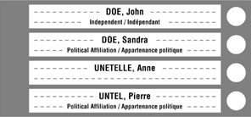
However, if you are voting by special ballot, you will not see a list of candidates on the ballot. Instead, you will see a blank space where you will write the first and last name of the candidate you choose.
Candidate: A person who is trying to get elected.

Elections Canada: The official organization that runs the federal election.

Election day: The main day when people vote. This year, it is Monday, September 20, 2021.

Independent: A candidate or politician that is not part of any political party.
Member of Parliament (MP): MPs are elected officials in the federal House of Commons. They meet in Ottawa to create laws. They also have offices in the areas they represent. Each area (or riding) in Canada will vote for one MP to represent them in the federal House of Commons.

(Political) party: A group of people who have similar ideas and stances on issues. Some of their members are candidates trying to get elected, so that when elected, they can carry out their party’s ideas.
Platform: A party’s or candidate’s platform is the policies and values that they promise to carry out if elected. It tells voters where the party or candidate stands on major issues.
Polling station: The place where you can go to vote.

Riding: Ridings are geographical areas represented by one member of Parliament. Your riding is the one where your home address is. A riding is also called an electoral district. Each riding will select one candidate to be the new MP for that area.

Special ballot: If you are voting by special ballot, you will not see a list of candidates on the ballot. Instead, you will see a blank space where you will write the first and last name of the candidate you choose.

Voter (information) card: If you registered ahead of time, you will receive a voter card by mail that tells you where you can vote. If you bring it with you when you vote, it helps the election workers know that you are registered.

This is what it looks like:
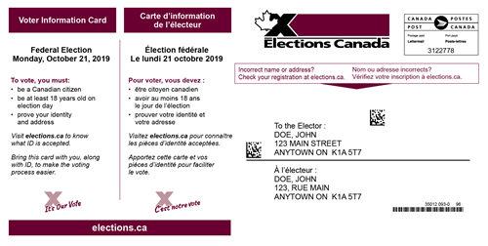
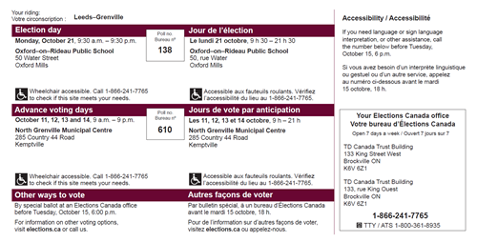
Vouch: To confirm that something is true. If you do not have an acceptable ID or if you are living in a long-term care institution, someone can vouch for your identity and address. See details in the “what you need to bring” section.

The Elections Canada website has a more detailed glossary (not in plain language).

Thank you for participating in the election process! Voting is only the first step in making a more democratic and just Canada. There are many other ways for autistic people to be engaged in political processes throughout the year. Join your local Autistics United Canada chapter to learn more about how you can get involved!

